* **Data Access:**

Here is the SQL query to extract the dataset from udacity, Since I live in Jeddah, mecca is the nearest city to me, so I export the data of city level for mecca then I download it as CSV.

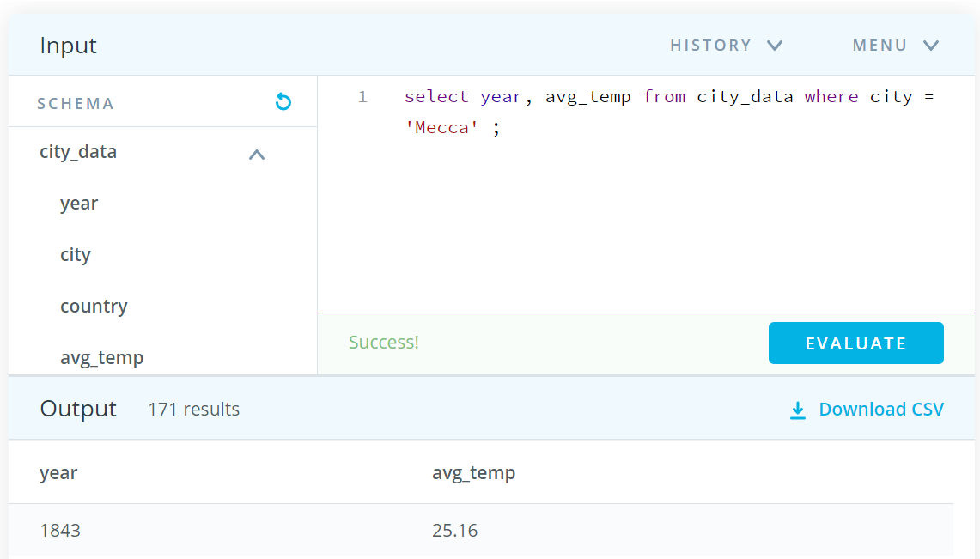

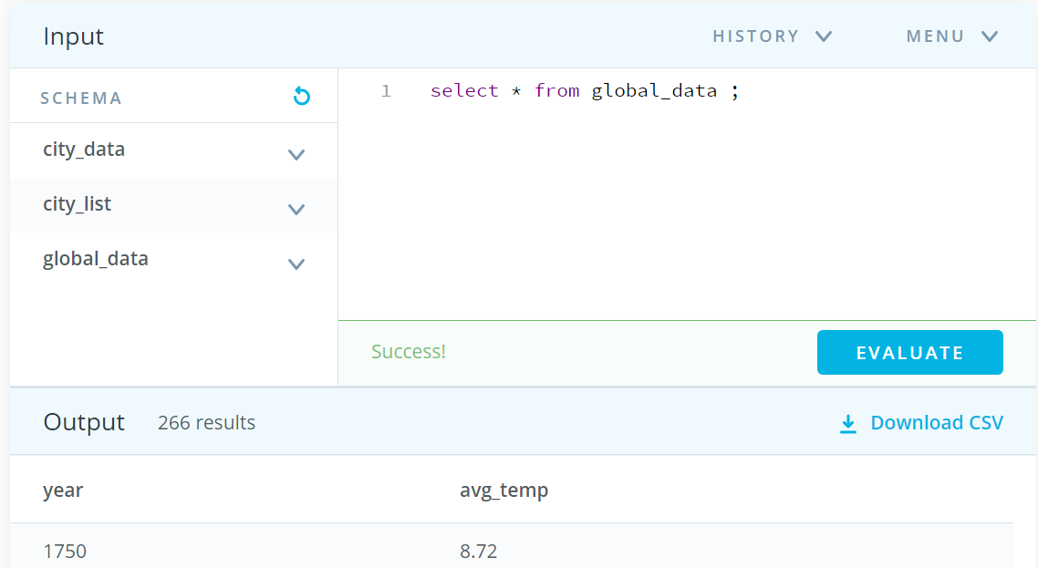

* **Data Preprocessing:**

I used python with Jupyter Notebook to check the missing values., then I found that there is 15 rows missing so to handle it I chose to fill the missing value with median.

Also not all the years with global data is present in mecca, so I remove the years from global starting from1750 to 1842 using EXCEL.

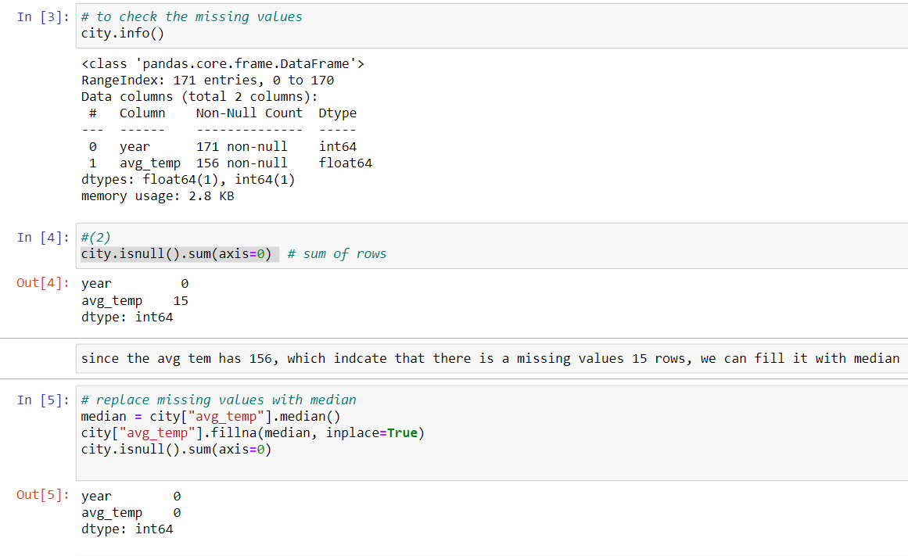

* **Data Exploration:**

Icalculated the 14 years- moving average using Excel with function ( average) .

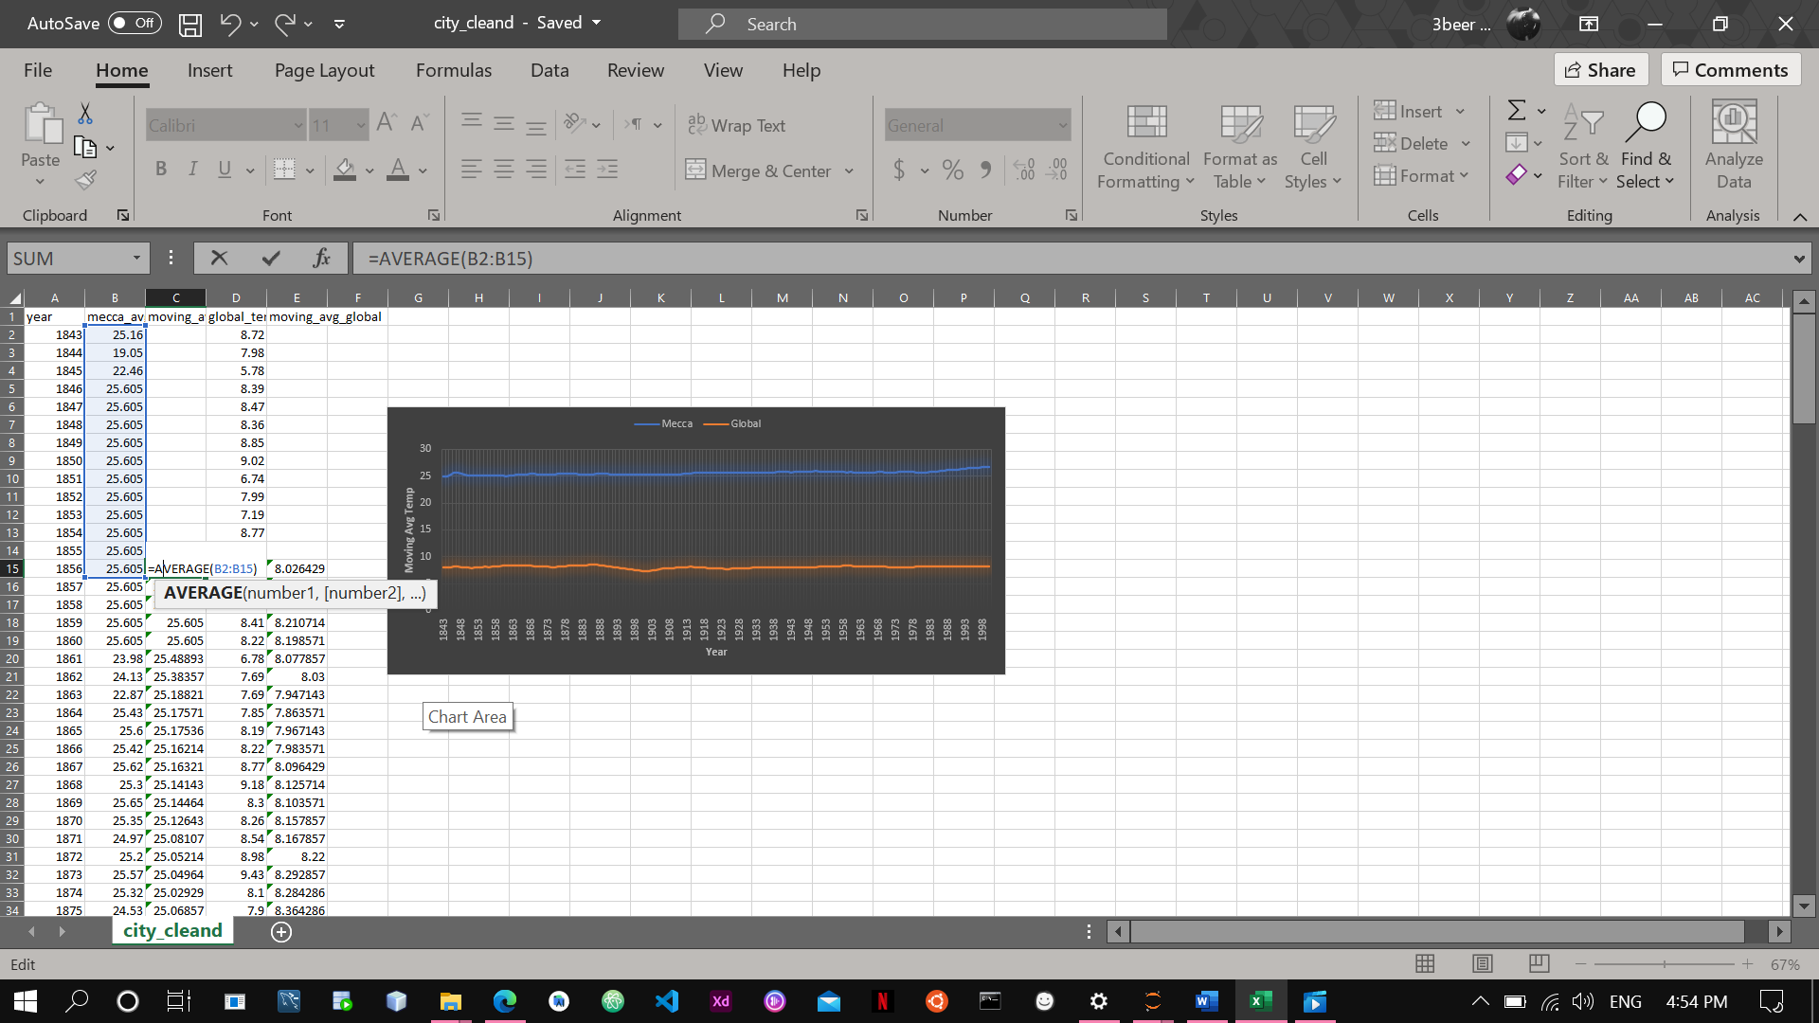

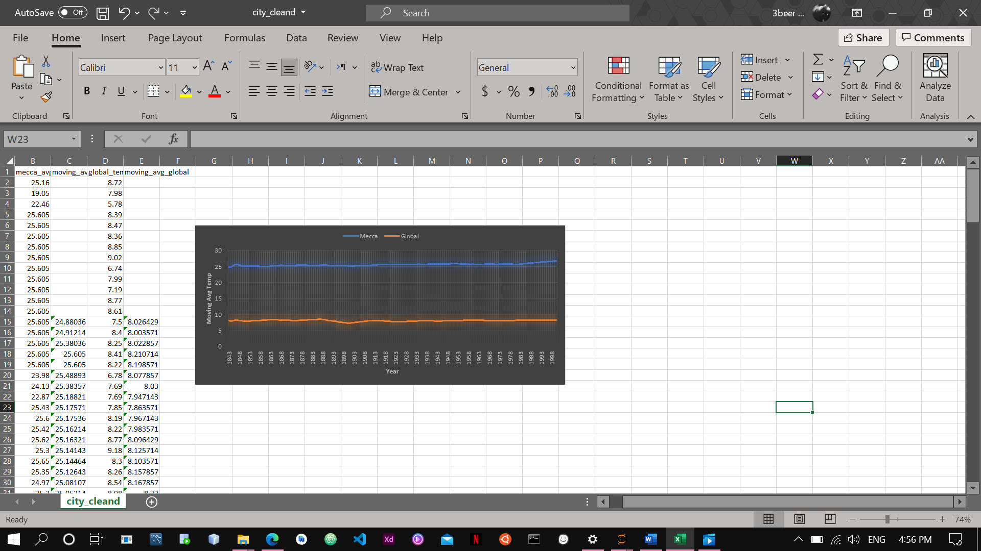

* My Observations:

1. The moving temp for mecca compared to the global temp is high according to the line chart.
2. From 1880 to 1898 there is downward for global temp while mecca stand constant.
3. From 1983 to 1998 both the global temp and mecca is raised.
4. The correlation coefficient for mecca city from 2000 – 2013 is strong.

